UNDERWRITING SUBMISSION

- COMPANY NAME:

- GROSS ASSETS: (Defined as Property, Plant and Equipment without deduction for depreciation, amortization or depletion plus inventories, materials and supplies as reflected in the most recent Annual Report) Gross Assets are to be broken down by sector. For sector definitions, please refer to Exhibit A. Gross Assets should be prepared in a manner consistent with US GAAP or IFRS.
SECTOR | PROPERTY PLANT & EQUIPMENT AT COST | INVENTORIES, MATERIALS & SUPPLIES | NON-CONSOLIDATED SUBSIDIAIRIES [*] | TOTAL UNMODIFIED GROSS ASSETS | %
Biofuels & Biochemicals
Electrical Storage
Electrical Utilities
Hydrogen
Mining
Offshore Carbon Capture & Storage
Offshore Exploration & Production
Offshore Wind
Onshore Carbon Capture & Storage
Onshore Exploration & Production
Onshore Wind
Other
Pharmaceuticals
Pipeline Operations
Refining & Marketing / Chemicals
Solar
Total

Members with windstorm exposure MUST declare their DNWS assets to Everen separately via the DNWS Declaration template. Everen also requires additional Replacement Cost Value data based on all DNWS assets in excess of $5,000,000 (DNWS Asset Location Declaration template attached).

[*] NON-CONSOLIDATED SUBSIDIARIES
Please identify all non-consolidated subsidiaries which are to be insured pursuant to paragraph 3 of Exhibit D-1 or D-2. Coverage for JV affiliates / 3rd Parties that are Non-Everen members will be subject to guidelines and underwriter approval.

NAME OF COMPANY/ AFFILIATE | EFFECTIVE  DATE | SECTOR | INSUREDS % INTEREST | 3rd PARTY % INTEREST | TOTAL GROSS ASSETS ($USD) | % OF GROSS ASSETS TO BE INSURED | PLEASE IDENTIFY OTHER PARTNERS AND THEIR INTEREST

Signature: _________________________

- RENEWAL DATE:

- PREMIUM OPTION: (please check one of the following. For an explanation of the different premium options, refer to Exhibit B)

- Flat Premium Option YES NO
If “YES” please check one of the following Quota Share Retentions:-
0% 10% 20% 30%

- Standard Premium Only (40% Quota Share Retention)
YES NO

- Retrospective Premium Plan (only available to members with investment grade credit ratings)
If “YES” please check one of the following Pool Participation %’s:-
- Business Sectors only YES NO (check one)

10% 20% 30% 40%

- Offshore /Onshore Excess Pools: YES NO (check one)

10% 20% 30% 40%

- DEDUCTIBLE:

$ (Non-Windstorm) $ (Windstorm)

The minimum deductible for both non-windstorm and windstorm is $10 million.) If a different deductible is required in any sector, please indicate:

- LIMITS (per occurrence/per sector):

$ (Non-Windstorm) $ (Windstorm)

If a different limit is required in any sector, please indicate below (maximum limit $450M (Non-Windstorm) and $150M part of $250M (Windstorm Excess Pools) :

7) BROKER ACCESS: (please check your option)

Brokered or Non-Brokered

If Brokered, Everen pays a 15% Brokerage Commission for the first year ONLY. In the subsequent years, members have the option of electing an annual brokerage commission percentage or amount. The brokerage commission will be displayed separately on a member’s invoice, if applicable.

8) LOSS HISTORY: Please submit together with this form, a 10 year loss history for Property Damage and Pollution claims in excess of $5 million from the ground-up on a non-trended/development basis. Officer sign off is required.

9) ANNUAL REPORT: An electronic copy of the most recent Annual Report should be submitted with this request for a premium indication.

10) CREDIT RATING: Please indicate Standard & Poor’s (S&P) and/or Moody’s ratings.
Standard & Poor’s Moody’s

11) PRIVATE COMPANIES: If a private company, identify principal owners, ownership structure and operators of business units. Provide a written description of business operations and how they manage their Risk Management functions. (Everen will sign confidentiality agreements if requested)

12) LOSS CONTROL: Does the prospect have an established loss control/safety department within the Company and what is its reporting structure within the organization? If an external firm is used to provide loss control, please advise the name and a description of the processes utilized.

13) SANCTIONABLE ACTIVITY – GROSS ASSET DECLARATION:
Exclusion 34 excludes coverage for losses arising out of any sanctioned activity.

As part of the asset declaration process, completion of the Sanctionable Activity - Gross Asset Declaration template is required (officer sign-off required). These assets will be deducted from a member’s total gross assets and will not be included for premium determination purposes.

14) DESIGNATED NAMED WINDSTORM (DNWS): Please complete the attached DNWS asset declaration and DNWS asset location template. Officer sign off is required.

15) JOINT VENTURES: Name/location of significant joint venture operations with current Everen members (identify members):

16) EXCESS INSURANCE ENDORSEMENT: The Everen policy will respond in excess of any other valid and collectible insurance in accordance with Condition G of the Everen Shareholders’ Agreement. If your company requires Everen to respond as primary to certain policies, please advise below:

YES NO (check one)
If “YES” please complete the attached Excess Insurance Endorsement Schedule (and template).

17) OPOL PRIORITY OF COVERAGE & PAYMENTS ENDORSEMENT:
Does your company require the OPOL Endorsement (per Exhibit H of the Everen Shareholders’ Agreement) to be attached to their Everen policy?

YES NO (check one)

18) DIAGRAM OF PROGRAM STRUCTURE: A diagram of the current insurance program should be provided showing the name of underwriters, if any, providing underlying and/or excess Everen-type coverage and specific limits purchased. Also, provide amount/placement of self-insured retentions.

19) COMMERCIAL MARKET UNDERWRITING SUBMISSION: Please provide a copy of your company’s most recent commercial market underwriting submission.

20) USE OF CAPTIVE INSURANCE COMPANY:
If the prospective member has a Captive, please identify the name and location of the Captive below.

21) CONTACTS: Please advise the contact details for the company representative and insurance broker(s) for our records:

Company Contacts:

NAME | TITLE | EMAIL ADDRESS | DIRRECT LINE #

Broker Contacts:

NAME | TITLE | EMAIL ADDRESS | DIRRECT LINE #

For Internal Use Only:

Reviewed by: Date: .

Approved by: Date: .

EXHIBIT A

Schedule 2

SECTOR & GEOGRAPHIC REGION DEFINITIONS

This schedule defines the Sector & Geographic Region definitions, approved by the Board of Directors, to be used for the purposes of reporting Unmodified Gross Assets and Named Windstorm Unmodified Gross Assets pursuant to Sections IV.C and IV.D of the Rating & Premium Plan. For the avoidance of doubt, this schedule is reproduced for convenience only; it does not form part of the Rating & Premium Plan and should not be used for any coverage guidance or interpretation. The language of the policies shall be controlling in all cases.

The definitions of the terms defined in the Shareholders’ Agreement and exhibits thereto are incorporated by reference into this Schedule.

SECTOR DEFINITIONS

The Sector definitions, as approved by the Board of Directors on December 8, 2022 (effective January 1, 2023), are as follows:

“Biofuels & Biochemicals” means the Sector for reporting Unmodified Gross Assets in respect of companies or business operations engaged in the manufacturing, refining, transportation (excluding Pipeline Operations), distribution, marketing, and/or sale of biofuels and/or biochemicals. Biofuel means a fuel that is produced over a short time span from raw, processed, and/or waste matter of biological or renewable origin, and includes, without limitation, biogas, renewable natural gas, renewable propane, biodiesel, renewable diesel, and renewable naphtha. Biochemical means a chemical that is produced from raw, processed, and/or waste matter of biological or renewable origin.

“Electrical Storage” means the Sector for reporting Unmodified Gross Assets of companies or business operations engaged in the storage of electrical energy.

“Electric Utilities” means the Sector for reporting Unmodified Gross Assets (other than those accounted for under another business Sector) of companies or business operations engaged in the generation (excluding co-generation electricity plants located within or adjacent to refinery complexes), transmission, distribution, marketing, and/or sale of electrical energy. Concentrated solar power or concentrated solar thermal systems shall be reported under this Sector.

“Hydrogen” means the Sector for reporting Unmodified Gross Assets in respect of companies or business operations engaged in the manufacturing, transportation (excluding Pipeline Operations), distribution, marketing, and/or sale of hydrogen.

“Mining” means the Sector for reporting Unmodified Gross Assets of companies or business operations engaged in the exploration, mining, and/or extraction of:

(1) mineral deposits or ores,

(2) coal,

(3) oil sands for transportation to extraction plants, and/or

(4) bitumen by a hot-water wash (often referred to as the steam process).

“Offshore Carbon Capture & Storage” means the Sector for reporting Unmodified Gross Assets that are physically located Offshore (including Pipelines) in respect of companies or business operations engaged in the capture, transportation, processing, storage, and/or sequestration of carbon dioxide.

“Offshore Exploration & Production” means the Sector for reporting Unmodified Gross Assets that are physically located Offshore (including Pipelines) in respect of companies or business operations engaged in the exploration, development, production, processing, and/or on-site storage of hydrocarbons.

“Offshore Wind” means the Sector for reporting Unmodified Gross Assets that are physically located Offshore (including cables) in respect of companies or business operations engaged in the generation, and/or transmission of electrical energy from wind energy resources.

“Onshore Carbon Capture & Storage” means the Sector for reporting Unmodified Gross Assets that are physically located Onshore in respect of companies or business operations engaged in the capture, transportation, processing, storage, and/or sequestration of carbon dioxide.

“Onshore Exploration & Production” means the Sector for reporting Unmodified Gross Assets that are physically located Onshore in respect of companies or business operations engaged in

(1) the exploration, development, production, processing, and/or on-site storage of hydrocarbons, and/or

(2) the extraction of bitumen from oil sands by the Steam Assisted Gravity Drainage Process (SAGD) (the drilling of injection and production wells, steam injection in order to separate the bitumen from the sand, and collection of the bitumen and pumping it to the surface).

“Onshore Wind” means the Sector for reporting Unmodified Gross Assets that are physically located Onshore in respect of companies or business operations engaged in the generation, and/or transmission of electrical energy from wind energy resources.

“Other” means the Sector for reporting Unmodified Gross Assets that do not qualify under any of the other Sector definitions.

“Pharmaceuticals” means the Sector for reporting Unmodified Gross Assets of companies or business operations engaged in the discovery, development, manufacturing, and/or marketing of vaccines, prescription and over-the-counter medicines, and/or health-related products for humans and/or animals.

“Pipeline Operations” means the Sector for reporting Unmodified Gross Assets that are physically located Onshore (other than those accounted for under another business Sector) in respect of:
(1) companies or business operations engaged in the transportation via Pipelines, processing, terminaling, and/or storage of fluids, and/or

(2) underground cables.

“Refining & Marketing / Chemicals” means the Sector for reporting Unmodified Gross Assets (other than those accounted for under another business Sector) in respect of:

(1) companies or business operations engaged in the manufacturing, refining, transportation (excluding Pipeline Operations), distribution, marketing, and/or sale of:

- motor gasoline,

- distillate fuels,

- lubricants,

- synthetic crude oil refined (upgraded) from bitumen extracted from oil sands,

- other refined products derived from hydrocarbons (including synthetic crude oil), and/or

- chemicals of all types other than Pharmaceuticals, and/or

(2) co-generation electricity plants located within or adjacent to refinery complexes.

“Solar” means the Sector for reporting Unmodified Gross Assets (other than those accounted for under another business Sector) of companies or business operations engaged in the generation, and/or transmission of electrical energy from solar energy resources.

*************************************************************************************************************

Note: Inventories should be classified under the business sector in which they are accounted for.

GEOGRAPHIC REGION DEFINITIONS
The maps presented below are for illustrative purposes only, the Geographic Region definitions are controlling.

The Geographic Region definitions, as approved by the Board of Directors on December 6, 2012, and subsequently amended on March 21, 2017 (effective January 1, 2018), are as follows:

The “Offshore Gulf of Mexico Geographic Region” is the Offshore portion of the Gulf Of Mexico.

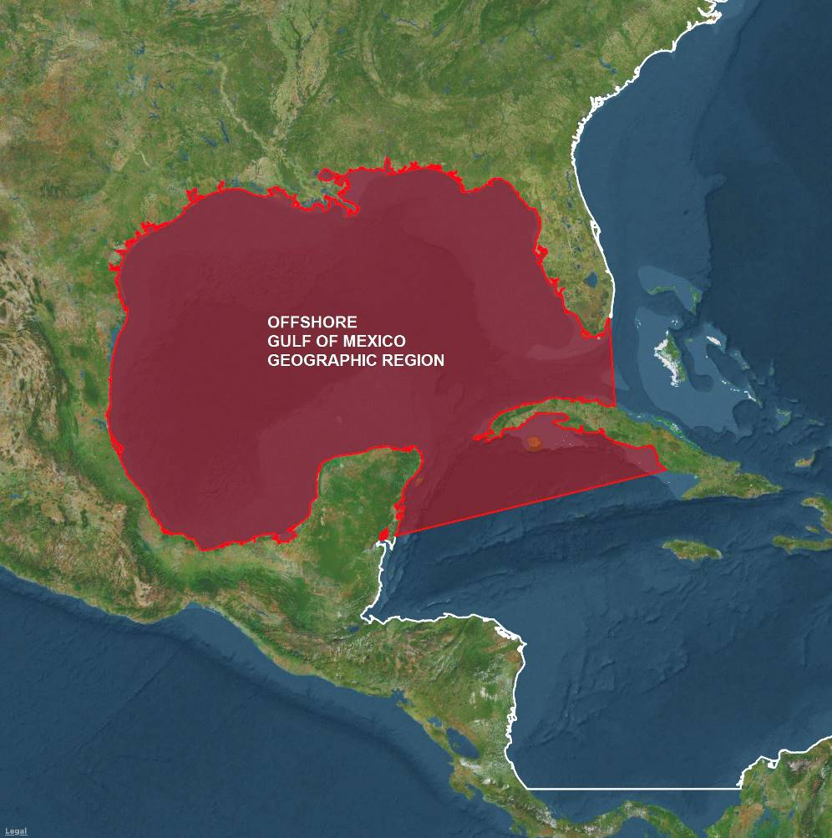

The “Onshore Gulf of Mexico Geographic Region” is the Onshore Coastal areas appurtenant to (and islands within) the Offshore Gulf of Mexico Geographic Region.

The “Offshore Upper Atlantic Geographic Region” is the portion of the Atlantic Basin (i.e., Offshore areas only) bounded to the south by the latitude of the most easterly point of the border of the states of Florida and Georgia.

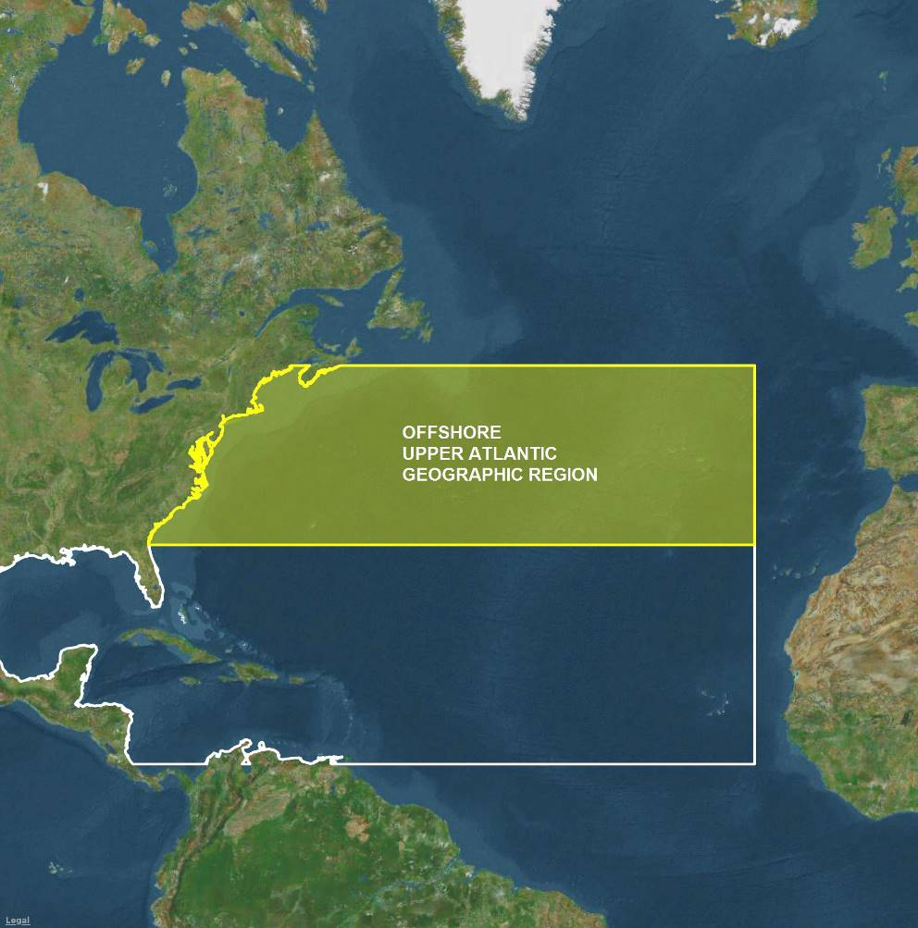

The “Onshore Upper Atlantic Geographic Region” is the Onshore Coastal areas appurtenant to (and islands within) the Offshore Upper Atlantic Geographic Region.

The “Offshore Non-Gulf of Mexico, Caribbean & Mid-Atlantic Geographic Region” is the portion of the Atlantic Basin (i.e., Offshore areas only) bounded to the west and north-west by the Offshore Gulf of Mexico Geographic Region and bounded to the north by the latitude of the most easterly point of the border of the states of Florida and Georgia, and bounded to the south by latitude 11.5° north.

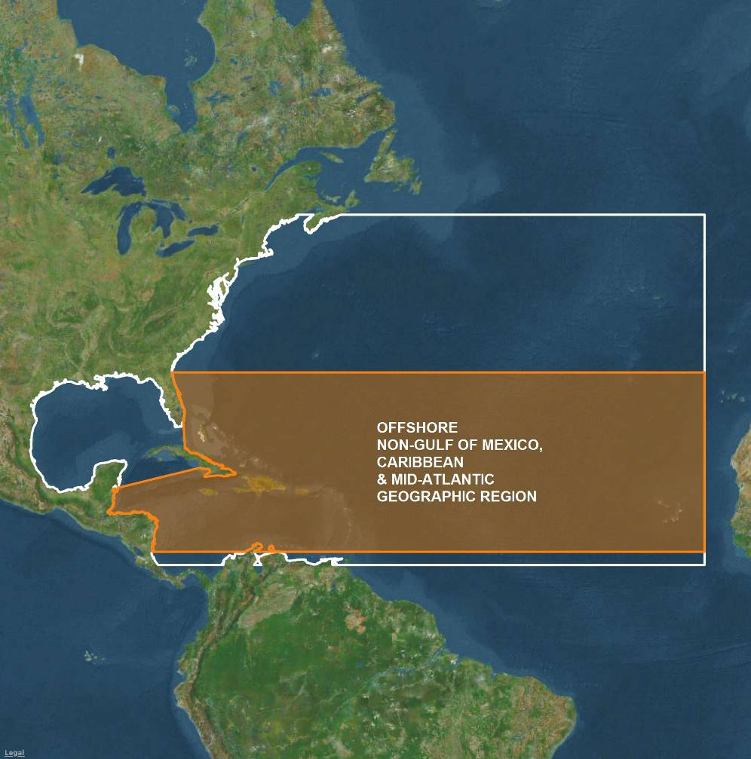

The “Onshore Non-Gulf of Mexico, Caribbean & Mid-Atlantic Geographic Region” is the Onshore Coastal areas appurtenant to (and islands within) the Offshore Non-Gulf of Mexico, Caribbean & Mid-Atlantic Geographic Region.

The “Offshore Lower Atlantic Geographic Region” is the portion of the Atlantic Basin (i.e., Offshore areas only) bounded to the north by latitude 11.5° north.

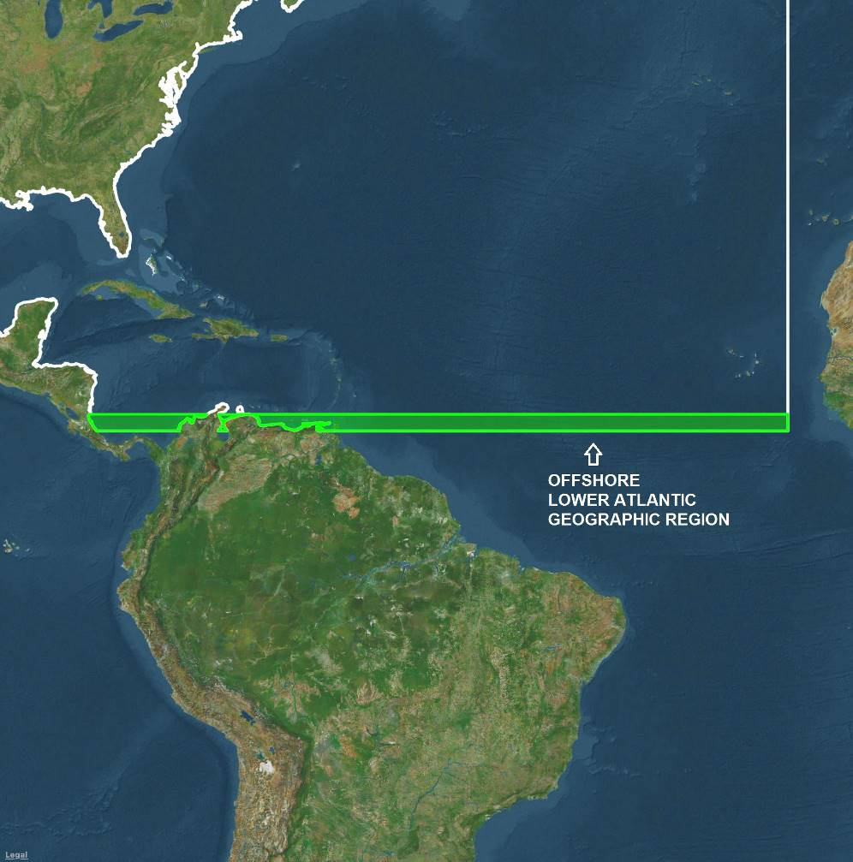

The “Onshore Lower Atlantic Geographic Region” is the Onshore Coastal areas appurtenant to (and islands within) the Offshore Lower Atlantic Geographic Region.

EXHIBIT B

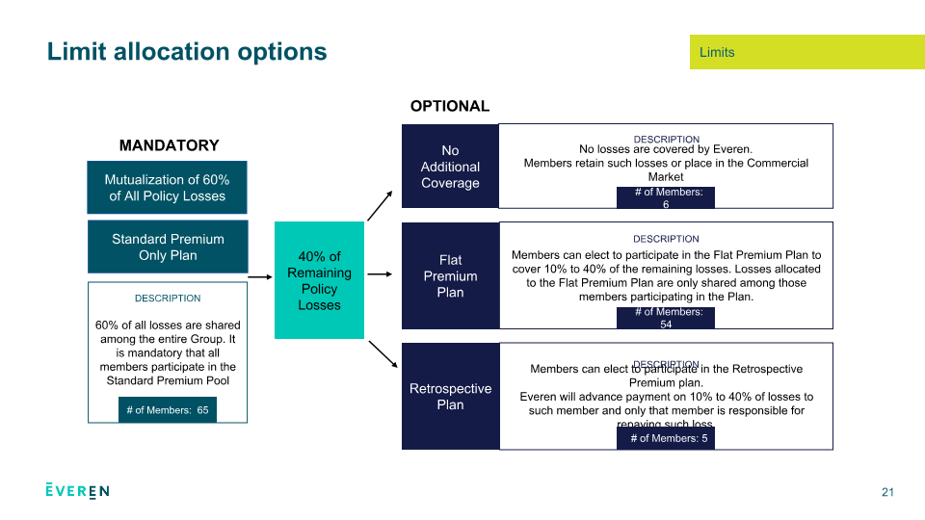

- Standard Premium Only Option (Mandatory): If a member elects this option, they are entitled to a limit of $270M (60% of $450M). The 40% quota share ($180M) may be retained by the member or insured in the commercial market.

- Flat Premium Option: By electing the Flat Premium option (Pool B) with a 0% quota share, a member has 100% mutualization (60% coverage under the Standard Pool and 40% coverage under the Flat Pool). Alternatively by electing a 10%, 20% or 30% Flat Premium internal quota share, they will be reducing the $450M limit (or reduced limit) proportionately.

- Retrospective Premium Plan – Business Sectors (Non-Windstorm): If a member elects this option, they are entitled to the full $450M limit but will be required to pay back a retro premium over 5 years (for the 40%) based on their individual losses. The payback is on a straight-line basis. If this option is required, select “Yes” and check 40% participation (for the full $450M limit). Alternatively, by electing 10%, 20% or 30% participations, the $450M limit will be reduced to $315M, $360M or $405M respectively.

- Retrospective Premium Plan – Offshore/Onshore excess pools (Windstorm): For the Offshore/Onshore excess pools, a member is entitled to a maximum per shareholder limit of $150M part of $250M limit. For the remaining $100M (40% of $250M), a member could: 1) Retain/self-insure, (2) Purchase in the commercial market, (3) Elect coverage from Everen under the Retro Plan or (4) Combine one or more of the above options.

If you require coverage for the full $100M uncovered portion, select “Yes” and check 40% participation. This will entitle you to the full $250M limit for windstorm. Alternatively, by electing 10%, 20% or 30% participations, the $250M limit will be reduced to $175M, $200M or $225M respectively. In the event of a loss, a retro premium will be payable over 5 years on a straight line basis.

If you do not wish to elect retro coverage for either the business sectors or the windstorm excess pools, check “No” in each category

** Please note that the Retrospective Premium option (for the Business sectors and DNWS) is only available to members that have an investment grade (or above) credit rating, as approved by shareholders at Everen’s March 2019 AGM.

